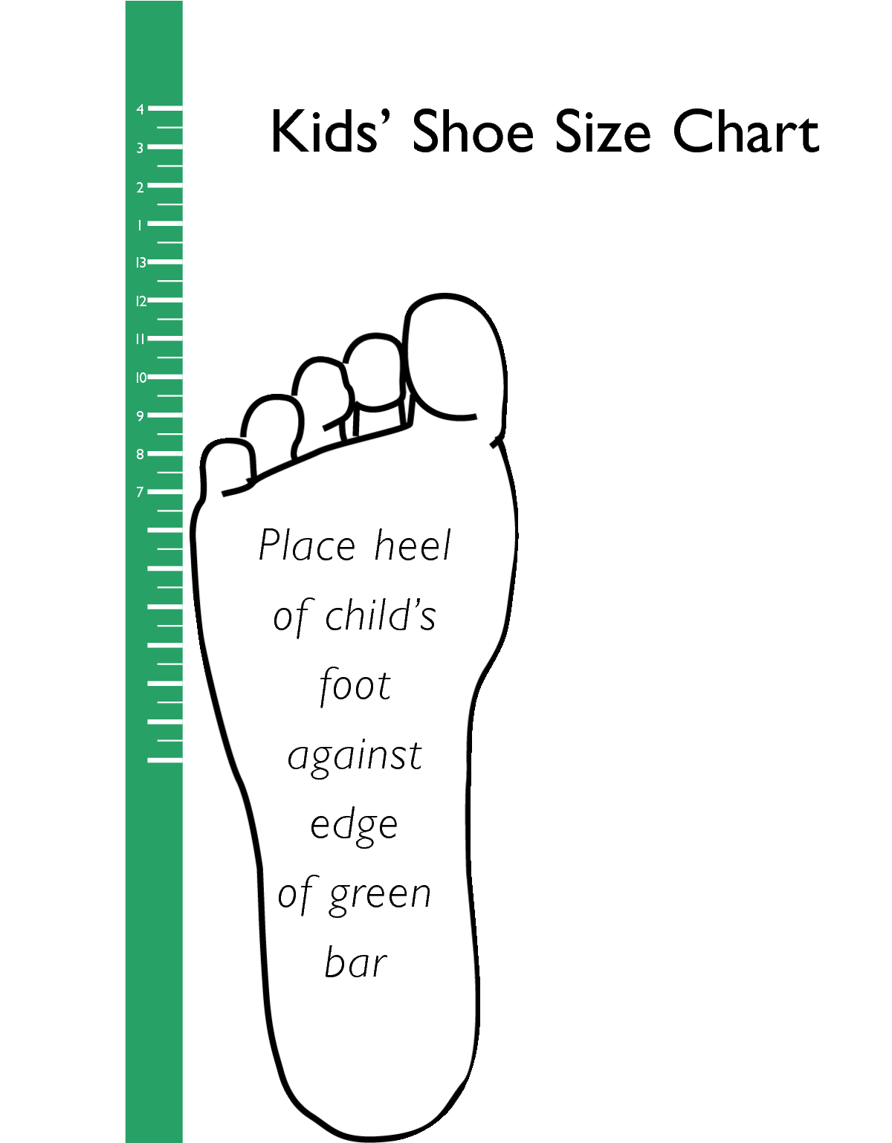

Operation School Bell offers children’s sizes **8 through 4** and adult sizes **5 through 13**.